Thread Management using POSIX Library - Detachment and Cancellation assignments

Mandatory

- Write a program to create 3 threads with the detach and cancel status as below.

Thread# | Detached (Y/N) | Cancel type | Cancel status
1 | Y | PTHREAD_CANCEL_DISABLE
2 | N | PTHREAD_CANCEL_ENABLE | PTHREAD_CANCEL_DEFERRED
3 | N | PTHREAD_CANCEL_ENABLE | PTHREAD_CANCEL_ASYNCHRONOUS

- Let all the threads read and display their detach, cancel type and status and then display thread specific message as below.
T1: Display message in the format as below every 2 secs
<timestamp> Health OK
T2: Print numbers starting from 1000 in steps of 2 at an interval of 3 secs in format as below.
<timestamp> <threadid> <countvalue>

T3: Print numbers starting from 2000 in steps of 2 at an interval of 3 secs
<timestamp> <threadid> < countvalue >
Ans:
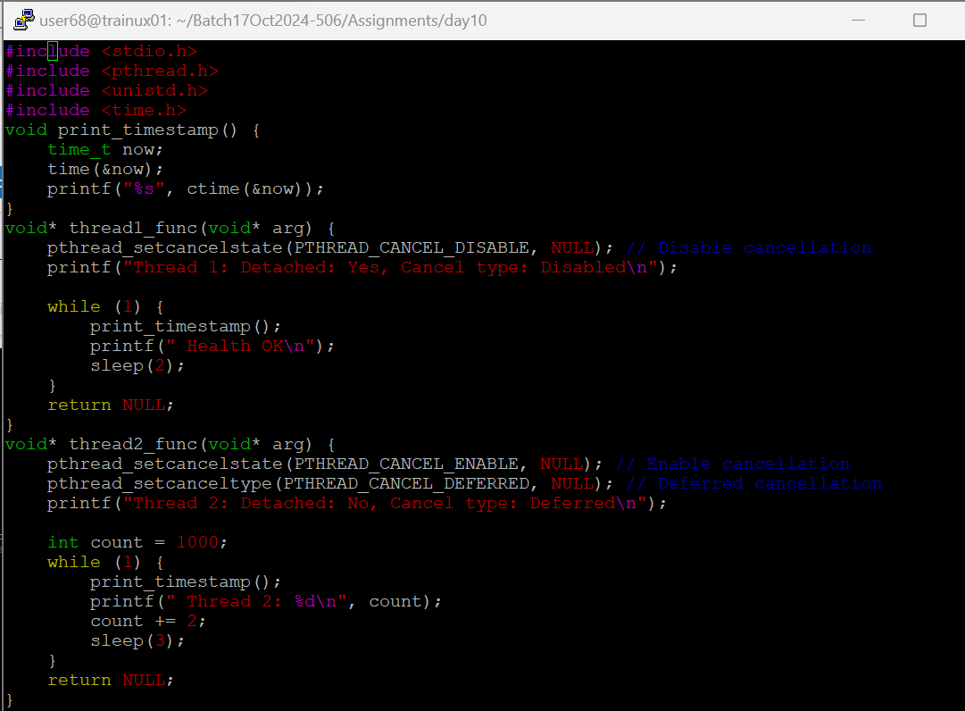
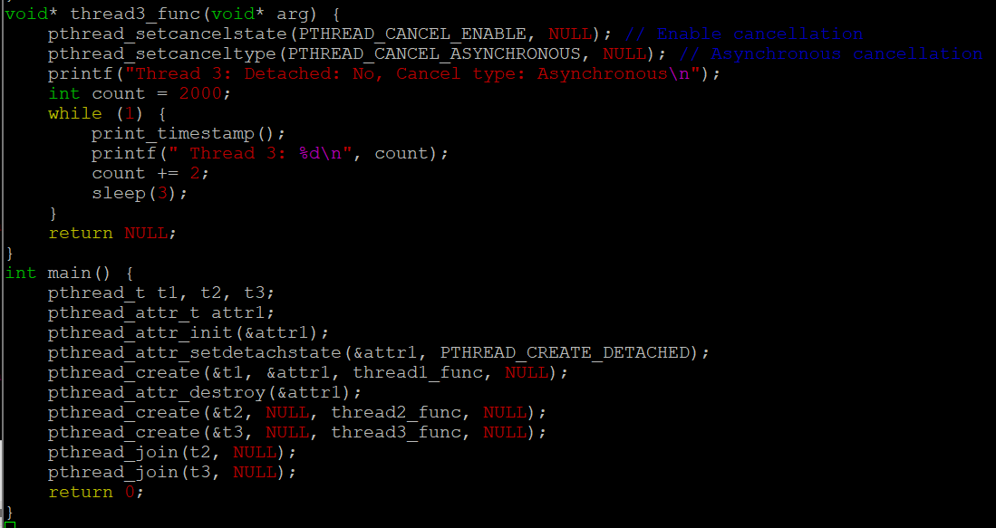
- After creating threads, and after 3 minutes from main(), cancel all 3 threads
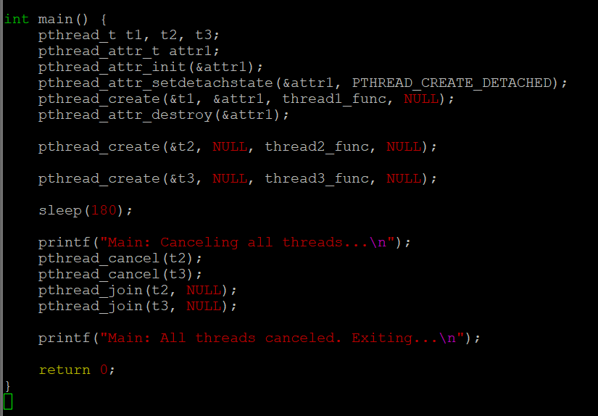
- From an other terminal, use command below to view the thread count of your program
    - ps -eLF
    - top
[For top command usage to refer https://www.golinuxcloud.com/check-threads-per-process-count-processes/ ]
- What difference did you observe between top and ps command?
Ans: top should be used to see which processes are most active, ps could be used to see which processes are running currently.

- Which column shows the number of threads in ps and in top commands?
Ans: In ps -eLF, the NLWP column shows the number of threads.
In top, the THR column shows the number of threads for each process.

- Check the last message timestamp from the threads
Ans: Thread 3 is canceled first because it uses PTHREAD_CANCEL_ASYNCHRONOUS, meaning it is canceled immediately

- Which thread was cancelled first and why?
Ans : Yes, all threads were canceled. However, Thread 3 was canceled immediately. Thread 2 was canceled after the sleep, and Thread 1 was canceled but since it was detached, it might not have been joined.
- Were all 3 threads cancelled? Justify the observation
Ans : When you execute the program and cancel the threads after 3 minutes, the behavior of each thread depends on its cancellation settings (PTHREAD_CANCEL_ENABLE or PTHREAD_CANCEL_DISABLE) and cancellation type (PTHREAD_CANCEL_DEFERRED or PTHREAD_CANCEL_ASYNCHRONOUS).

